**Data Flow Diagrams:**

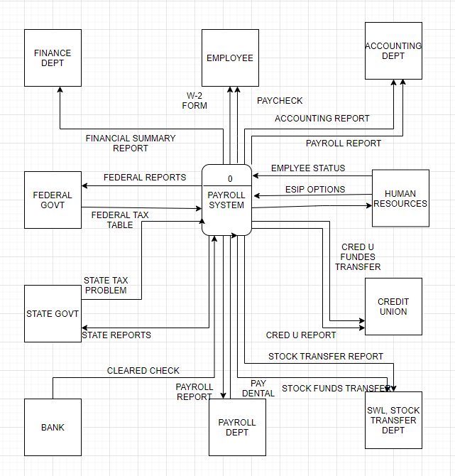

**Figure** Final context diagram for SoftWear Limited’s payroll system

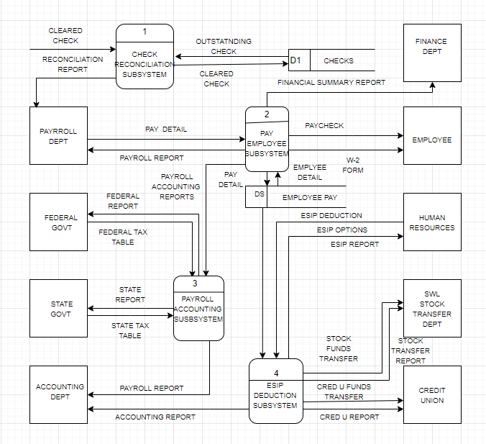

**Diagram 0** DFD for SoftWear Limited’s payroll system.